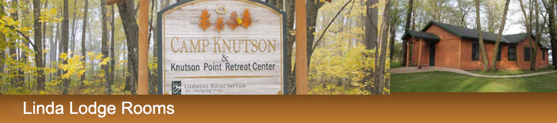

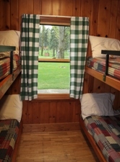

Linda Lodge’s close proximity to the dining center and large sleeping capacity makes these cabins perfect for large groups.
Cabins feature:
- Eight rooms with four bunk-style beds each
- Wide, comfortable bunk-beds
- Two large wheelchair accessible bathrooms with multiple showers and sinks
Plan room assignments:
Room One | Room 2 | Room 3 | Room 4
Bunk 1  Upper:  Lower: | Bunk 1  Upper:  Lower: | Bunk 1  Upper:  Lower: | Bunk 1  Upper:  Lower:
Bunk 2  Upper:  Lower: | Bunk 2  Upper:  Lower: | Bunk 2  Upper:  Lower: | Bunk 2  Upper:  Lower:
Bunk 3  Upper:  Lower: | Bunk 3  Upper:  Lower: | Bunk 3  Upper:  Lower: | Bunk 3  Upper:  Lower:
Bunk 4  Upper:  Lower: | Bunk 4  Upper:  Lower: | Bunk 4  Upper:  Lower: | Bunk 4  Upper:  Lower:
Room 5 | Room 6 | Room 7 | Room 8
Bunk 1  Upper Bunk:  Lower Bunk: | Bunk 1  Upper Bunk:  Lower Bunk: | Bunk 1  Upper:  Lower: | Bunk 1  Upper:  Lower:
Bunk 2  Upper Bunk:  Lower Bunk: | Bunk 2  Upper Bunk:  Lower Bunk: | Bunk 2  Upper:  Lower: | Bunk 2  Upper:  Lower:
Bunk 3  Upper Bunk:  Lower Bunk: | Bunk 3  Upper Bunk:  Lower Bunk: | Bunk 3  Upper:  Lower: | Bunk 3  Upper:  Lower:
Bunk 4  Upper Bunk  Lower Bunk | Bunk 4  Upper Bunk  Lower Bunk | Bunk 4  Upper:  Lower: | Bunk 4  Upper:  Lower:
Notes:

